GOVERNMENT FINANCIAL EXPENDITURE ANALYSIS
An Interactive Business Intelligence Dashboard for Public Financial Management

Prepared by

Amos Onyeka
Data Analyst | Business Intelligence Developer

Tools Used:

- Microsoft Excel
- Microsoft Power BI
- DAX
- Power Query

July 2026

TABLE OF CONTENT

Contents
Executive Summary 3
BACKGROUND OF THE STUDY 4
CHAPTER 2 5
STATEMENT OF THE BUSINESS PROBLEM 5
CHAPTER 3 6
PROJECT OBJECTIVES 6
3.1 General Objective 6
3.2 Specific Objectives 6
CHAPTER 4 7
DATASET DESCRIPTION 7
CHAPTER 5 8
DATA CLEANING AND PREPARATION 8
5.1 Data Structure Verification 8
5.2 Missing Value Assessment 8
5.3 Duplicate Record Verification 8
5.4 Consistency Checks 8
5.5 Numerical Data Validation 8
5.6 Date Validation 9
5.7 Data Quality Outcome 9
METHODOLOGY 10
DASHBOARD OVERVIEW 11
7.1 Executive Dashboard 11
7.2 Operational Dashboard 11
KEY FINDINGS 13
RECOMMENDATIONS 14
CONCLUSION 15
APPENDICES 16

Executive Summary
This project presents a comprehensive analysis of government expenditure using Microsoft Excel and Microsoft Power BI. The objective was to examine expenditure patterns across ministries, departments, regions, funding sources, project status, procurement methods, payment methods, and beneficiaries to support evidence-based decision-making.
A structured dataset containing 251 financial transactions was cleaned, validated, and transformed into an interactive Business Intelligence dashboard. Data preparation involved identifying missing values, validating data consistency, checking for duplicate records, and ensuring the accuracy of categorical and numerical fields before analysis.
The resulting dashboards provide both executive-level and operational insights. The Executive Dashboard summarizes key performance indicators, expenditure distribution by ministry, region, funding source, and monthly spending trends. The Operational Dashboard offers deeper analysis of departmental expenditure, procurement methods, payment methods, project status, and top beneficiaries.
Key findings indicate that internally generated revenue (IGR) was the largest funding source for government expenditure, while expenditure varied considerably across ministries and regions. The analysis also identified notable spending on cancelled and delayed projects, highlighting the need for stronger project monitoring and accountability mechanisms.
Overall, the project demonstrates how Business Intelligence tools can transform raw financial records into meaningful insights that support budget planning, expenditure monitoring, and strategic public financial management.

CHAPTER 1

BACKGROUND OF THE STUDY
Effective public financial management is fundamental to economic development, transparent governance, and efficient service delivery. Governments are responsible for allocating substantial financial resources across ministries, departments, agencies, and public programmes to promote national development and improve citizens' welfare. Consequently, monitoring how public funds are allocated and utilized has become increasingly important in ensuring accountability, fiscal discipline, and value for money.
Traditionally, government expenditure has been monitored through static financial statements and spreadsheets. Although these methods provide financial records, they often make it difficult to identify expenditure patterns, compare spending across ministries and regions, monitor project performance, and support timely decision-making. As government financial operations become more complex, there is an increasing need for interactive analytical tools capable of transforming raw financial data into meaningful business intelligence.
Business Intelligence (BI) tools such as Microsoft Power BI enable decision-makers to analyse large volumes of financial data through interactive dashboards, performance indicators, and dynamic visualisations. These tools provide real-time insights into expenditure trends, funding sources, regional allocations, project implementation status, and departmental performance, thereby supporting evidence-based budgeting and improved financial governance.
This project applies Business Intelligence techniques to analyse a simulated government expenditure dataset. Using Microsoft Excel for data preparation and Microsoft Power BI for dashboard development, the project demonstrates how data analytics can support transparency, strengthen financial oversight, and improve strategic decision-making within the public sector.

CHAPTER 2

STATEMENT OF THE BUSINESS PROBLEM
Government institutions generate large volumes of financial transaction data on a daily basis. However, the availability of data alone does not guarantee effective financial management. Decision-makers often face challenges in identifying expenditure trends, evaluating budget implementation, monitoring project performance, and assessing whether public funds are being allocated efficiently across ministries, departments, and regions.
Without a centralized analytical reporting system, financial information may remain fragmented across spreadsheets and operational records, making it difficult to obtain timely insights needed for strategic planning and accountability. This can result in delayed decision-making, inefficient allocation of resources, inadequate project monitoring, and limited transparency in public financial management.
The challenge addressed by this project is therefore the transformation of raw government expenditure data into an interactive Business Intelligence solution that enables stakeholders to monitor expenditure patterns, evaluate financial performance, identify areas requiring management attention, and support informed policy and budgetary decisions.

CHAPTER 3

PROJECT OBJECTIVES

3.1 General Objective
The general objective of this project is to analyse government expenditure data using Microsoft Excel and Microsoft Power BI in order to identify expenditure trends, evaluate financial performance, and develop an interactive Business Intelligence dashboard that supports informed decision-making in public financial management.

3.2 Specific Objectives
The specific objectives of this project are to:
- Determine the total government expenditure during the period under review.
- Identify the major funding sources that financed government expenditure.
- Analyse expenditure distribution across ministries, departments, and geographical regions.
- Evaluate expenditure trends over time to identify monthly spending patterns.
- Assess project implementation status by comparing completed, ongoing, delayed, and cancelled projects.
- Identify the departments and beneficiaries that accounted for the highest government expenditure.
- Examine expenditure by procurement method and payment method.
- Develop an interactive dashboard that enables users to filter, explore, and monitor government expenditure from different analytical perspectives.
- Generate actionable insights and recommendations that can improve financial planning, budget allocation, expenditure monitoring, and public sector accountability.

CHAPTER 4

DATASET DESCRIPTION
The dataset used for this project is a simulated government financial expenditure dataset designed to reflect typical public sector expenditure records. It contains 251 transaction records and 24 variables, with each row representing an individual government expenditure transaction.
The dataset captures key financial and administrative information required for expenditure analysis, including transaction identification, expenditure amount, date, ministry, department, funding source, procurement method, payment method, project category, project status, beneficiary, geographical region, and budget classification.
The dataset was intentionally structured to resemble financial records commonly maintained by ministries, departments, and government agencies. This provided a realistic environment for demonstrating data cleaning, exploratory data analysis, dashboard development, and business intelligence reporting using Microsoft Excel and Microsoft Power BI.
Prior to analysis, the dataset underwent a comprehensive data quality assessment to ensure consistency, completeness, and accuracy of the records.

CHAPTER 5

DATA CLEANING AND PREPARATION
Data quality is a critical requirement for producing reliable and meaningful analytical results. Prior to analysis, the dataset underwent a structured data cleaning and validation process using Microsoft Excel. The objective was to ensure that the data was complete, consistent, accurate, and suitable for Business Intelligence reporting in Microsoft Power BI. The following data preparation activities were carried out.

5.1 Data Structure Verification
The dataset was reviewed to ensure that all variables were correctly organised into their respective columns. Data types such as dates, numerical values, and categorical variables were examined to verify consistency throughout the dataset.

5.2 Missing Value Assessment
The dataset was inspected for blank or incomplete records.
The assessment identified:
- One missing value in the Ministry column.
- One missing value in the Funding Source column.
These missing values were documented and addressed before dashboard development.

5.3 Duplicate Record Verification
The Transaction ID field was examined to confirm that each expenditure record possessed a unique identifier. The assessment confirmed that no duplicate transaction records existed in the dataset.

5.4 Consistency Checks
Categorical variables were reviewed to identify inconsistent spellings or duplicate category labels. Examples included:
- Ministry
- Region
- Department
- Budget Type
- Funding Source
- Procurement Method
- Payment Method
- Project Status
The review confirmed that the dataset maintained consistent naming conventions across all categorical fields.

5.5 Numerical Data Validation
The expenditure amount field was validated to ensure that:
- All values were numeric.
- No negative expenditure values existed.
- Currency values were correctly formatted for analysis.

5.6 Date Validation
The transaction date column was examined to ensure that all records contained valid date values. The Month and Quarter fields were also verified to support time-series analysis in Power BI.

5.7 Data Quality Outcome
Following the completion of the cleaning process, the dataset was considered fit for analysis. The cleaned dataset provided a reliable foundation for dashboard development and the generation of meaningful business insights. A detailed description of all dataset variables is provided in the Appendix (Data Dictionary).

CHAPTER 6

METHODOLOGY
This project adopted a descriptive data analytics approach to examine government expenditure patterns using Microsoft Excel and Microsoft Power BI. The methodology consisted of the following stages:
Data Collection: A simulated government expenditure dataset containing 251 transaction records and 24 variables was used.
Data Cleaning: Microsoft Excel was used to identify and correct missing values, validate data types, check duplicate records, and ensure consistency across categorical variables.
Data Analysis: Pivot Tables and Pivot Charts were created in Excel to perform exploratory analysis and identify expenditure trends.
Dashboard Development: The cleaned dataset was imported into Microsoft Power BI. DAX measures were created to calculate key performance indicators such as Total Government Expenditure, Average Expenditure, Transaction Count, Largest Transaction, and Number of Ministries.
Data Visualization: Interactive dashboards were developed using KPI cards, bar charts, column charts, line charts, slicers, and navigation buttons to support dynamic reporting.
Business Interpretation: The dashboard findings were analysed to identify expenditure trends, funding patterns, regional distribution, ministry performance, project status, and operational insights, leading to practical recommendations.
CHAPTER 7

DASHBOARD OVERVIEW
Two interactive dashboards were developed in Microsoft Power BI to present government expenditure information from both executive and operational perspectives.

7.1 Executive Dashboard
The Executive Dashboard provides a high-level summary of government expenditure. It includes Key Performance Indicators (KPIs) such as Total Government Expenditure, Average Expenditure, Largest Transaction, Transaction Count, and Number of Ministries. It also presents expenditure analysis by ministry, region, funding source, and monthly expenditure trend. Interactive slicers enable users to filter the report by Ministry and other relevant dimensions.
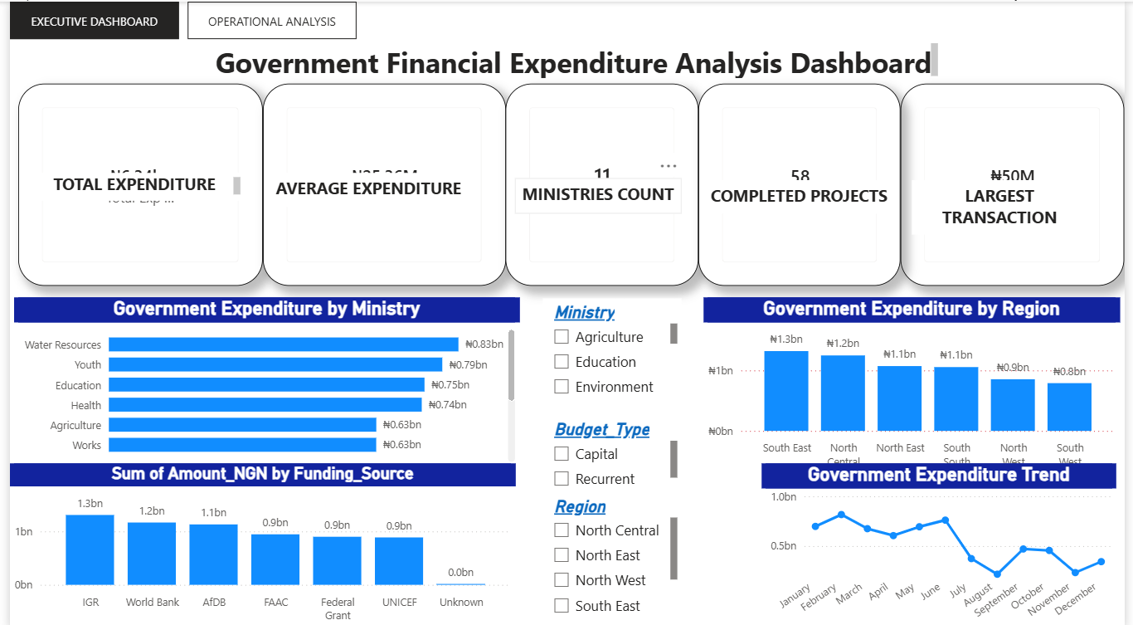

Figure 1: Executive Dashboard showing key expenditure indicators and expenditure trends.
Source: Developed by the Author using Microsoft Power BI (2026).

7.2 Operational Dashboard
The Operational Dashboard provides detailed operational analysis of government expenditure. It presents expenditure by department, beneficiary, procurement method, payment method, and project status. Interactive slicers allow users to analyse expenditure by Ministry, Department, Quarter, and Region, while navigation buttons enable movement between report pages.
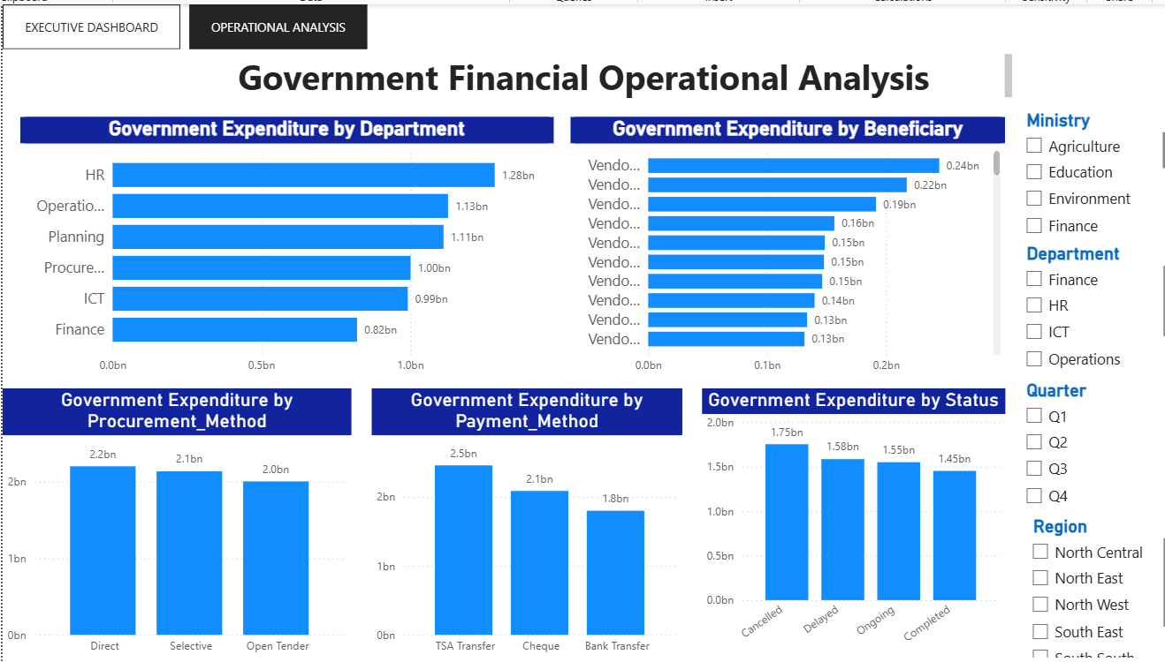
Figure 2: Operational Dashboard showing operational expenditure analysis
Source: Developed by the Author using Microsoft Power BI (2026).
CHAPTER 8

KEY FINDINGS
The analysis of the government expenditure dataset produced the following key findings:
- Total Government Expenditure amounted to approximately ₦6.34 billion, indicating significant financial investment during the period under review.
- Internally Generated Revenue (IGR) was the largest source of funding, suggesting that internally generated funds played a major role in financing government expenditure.
- The South East recorded the highest expenditure among all regions, while the South West recorded the lowest expenditure.
- Government expenditure varied considerably across ministries, indicating differences in operational responsibilities and budget allocations.
- The Human Resources Department recorded the highest departmental expenditure, while the Finance Department recorded the lowest.
- Analysis of project implementation status showed that a substantial proportion of expenditure was associated with Cancelled, Delayed, and Ongoing projects, highlighting the need for improved project monitoring and implementation.
- Procurement and payment methods exhibited different expenditure patterns, providing management with useful information for evaluating procurement efficiency and payment processes.
- Monthly expenditure trends fluctuated throughout the reporting period, demonstrating that government spending was not evenly distributed across the year.

CHAPTER 9

RECOMMENDATIONS
Based on the findings of this analysis, the following recommendations are proposed:
- Government should sustain and strengthen Internally Generated Revenue (IGR) initiatives, as IGR was the largest source of funding during the period under review.
- Expenditure across ministries and regions should be reviewed periodically to ensure equitable allocation of public resources and alignment with government priorities.
- A dedicated Project Monitoring and Evaluation Team should be strengthened or established to closely monitor ongoing and delayed projects, ensuring timely completion and preventing unnecessary project abandonment.
- The high level of expenditure associated with cancelled projects should be investigated to determine the underlying causes and to strengthen financial accountability and transparency.
- Procurement and payment processes should be reviewed regularly to improve efficiency, reduce delays, and ensure value for money.
- Government should continue to leverage Business Intelligence tools such as Microsoft Power BI for real-time expenditure monitoring, performance evaluation, and evidence-based decision-making.

CHAPTER 10

CONCLUSION
This project demonstrated how Business Intelligence tools can be used to transform raw government financial data into meaningful insights for decision-making. Using Microsoft Excel for data preparation and Microsoft Power BI for dashboard development, an interactive reporting solution was created to analyse government expenditure across ministries, departments, regions, funding sources, and project status.
The analysis revealed significant expenditure patterns, identified the major funding source, highlighted regional and departmental variations, and provided insights into project implementation. The dashboards enable decision-makers to monitor financial performance efficiently and support evidence-based planning and resource allocation.
Overall, the project illustrates the value of data analytics in strengthening transparency, accountability, and effective public financial management. It also demonstrates how interactive dashboards can enhance the monitoring and evaluation of government expenditure.

APPENDICES
APPENDIX A: DATA DICTIONARY
Column Name | Description | Data Type | Example | Business Rule
Transaction  ID | Unique identifier assigned to each financial transaction. | Text | GF0001 | Must be unique; no duplicates allowed.
Date | Date on which the expenditure transaction occurred. | Date | 15/01/2025 | Must fall within the reporting period.
Fiscal_Year | Government fiscal year in which the transaction was recorded. | Whole Number | 2025 | Must correspond with the transaction date.
Quarter | Fiscal quarter of the transaction. | Text | Q1 | Values limited to Q1–Q4.
Month | Calendar month derived from the transaction date. | Text | January | Must match the Date column.
Ministry | Government ministry responsible for the expenditure. | Text | Health | Cannot be blank.
Department | Department within the ministry responsible for processing the expenditure. | Text | Procurement | Should follow standardized naming conventions.
Agency | Government agency implementing or supervising the project or expenditure. | Text | Agency 7 | Should not be blank.
Region | Nigeria's geopolitical zone where the expenditure is allocated. | Text | South South | Only six valid geopolitical zones.
State | Nigerian state benefiting from or executing the project. | Text | Delta | Must correspond to the selected region.
LGA | Local Government Area where the expenditure occurred. | Text | LGA 5 | Should belong to the selected state.
Budget  Type | Classification of expenditure as Capital or Recurrent. | Text | Capital | Values limited to Capital or Recurrent.
Category | Broad expenditure classification. | Text | Infrastructure | Standardized categories only.
Subcategory | Specific expenditure activity within a category. | Text | Road Construction | Must logically belong to the selected category.
Funding_  Source | Source of funds used to finance the expenditure. | Text | FAAC | Should not be blank.
Procurement  Method | Method used to procure goods, services, or works. | Text | Open Tender | Must follow procurement regulations.
Payment  Method | Method used to disburse funds. | Text | TSA Transfer | Standardized payment methods only.
Beneficiary | Contractor, supplier, organization, or individual receiving payment. | Text | Vendor 15 | Should identify the recipient of funds.
Amount_NGN | Monetary value of the transaction in Nigerian Naira (₦). | Currency | 125,000,000 | Must be positive and realistic.
Status | Current implementation status of the project or transaction. | Text | Completed | Values limited to Completed, Ongoing, Delayed, or Cancelled.
Project_Manager | Officer responsible for supervising the project. | Text | Manager 4 | Should not be blank.
Approval_Level | Highest authority that approved the expenditure. | Text | Permanent Secretary | Must reflect the organization's approval hierarchy.
Performance_Rating | Assessment of project or departmental performance. | Text | Good | Values limited to Excellent, Good, Fair, or Poor.
Audit_Remark | Outcome of audit review for the transaction. | Text | Clean | Values limited to predefined audit remarks.

